Blog 03

“*Less than a quarter of the food wasted in the UK, US and Europe would provide enough to alleviate the world from food poverty*”, says [Tristram Stuart](https://www.tristramstuart.co.uk/), English author and food waste expert.

“*If food waste were a country, it would be the third largest emitter of greenhouse gases behind the US and China*”, says the Food and Agriculture Organization of the United Nations [(FAO)](http://www.fao.org/3/a-i3991e.pdf).[1]

“*Respect for food is respect for life. For who we are and what we do.*”, says [Thomas Keller](http://www.quolection.com/quotes/162), American chef, restaurateur and book writer. But can we talk of respect for food, when the European Union countries waste [several tens of millions tonnes](https://ec.europa.eu/food/sites/food/files/safety/docs/fw_eu-actions_ms_20160622_p01.pdf) of food per year? Comparing the tons of wasted food with the burdensome amount of 795 million people, approximately 1/9 of the people on Earth, that do not have enough food to lead a healthy active life[2], we should feel a bit ashamed. The scenario is even worse in the United States, where approximately half of the produced food is wasted[3]. The interested reader can refer to [this](https://www.nrdc.org/sites/default/files/wasted-food-IP.pdf) report from Dana Grunders, researcher at the non-profit environmental advocacy group [Natural Resources Defence Council](https://www.nrdc.org), for a detailed analysis of the losses and lack of efficiencies in the American food production chain.

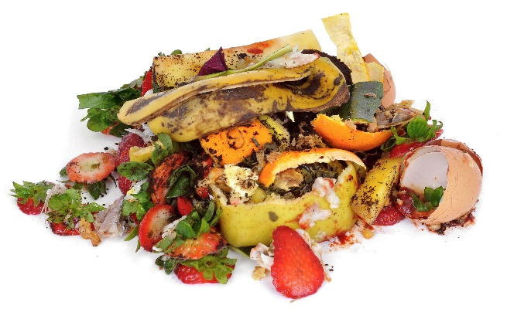The plague of food waste is typical of western modern developed countries, and along the years this problem became progressively more severe[4] while the world population kept increasing.

The question is: who wastes so much food? Should we blame the consumer who does not plan his meals properly and end up finding expired or even rotten food in his fridges? Or should we blame the supermarkets and distributors? Well, most probably there are some differences from developed country to developed country, but according to [Østfold Research Co.](http://sciencenordic.com/most-food-waste-households), which monitored the food waste in Norway, approximately two thirds of the total food waste comes from the households, i.e. from consumers like we and you.

How can the food waste problem be solved? For sure, it is not an easy question, it will take years to minimize the food waste, and most probably nullify the amount of wasted food is a utopian goal. Nevertheless, let’s try to analyse the problem: food waste is a defect of modern developed societies, where food is thrown away as waste because it is no longer edible or, most often, because it is theoretically expired and it is not saleable anymore. So, what these countries should try to do is to find alternative ways to use the food that currently is treated as waste. This is the typical problem that circular economy addresses!

In this post, we will focus on both sides of the coin: we will present alternative uses of unsaleable food and food close to the being thrown away from the retailers’ side and, on the other hand, we will have a word about the way households can optimize their food usage minimizing their waste.

Along the recent years, the issue of food waste seems to have gained more and more popularity, and actions both at the entrepreneurship level and that the legislative level have recently been taken. From the legislative side, we recall the introduction in 2013 in the United Kingdom of a voluntary [agreement](https://www.theguardian.com/business/2013/oct/21/uk-supermarkets-pressure-cut-food-waste) aiming to cut food and packaging waste in the supply chain. Something similar was introduced this year in [France](https://www.theguardian.com/world/2016/feb/04/french-law-forbids-food-waste-by-supermarkets), where a law, and not just an agreement, prevents food waste: with this law, supermarkets are forbidden to destroy or throw away unsold food, which is instead delivered to charities or food banks. The introduction of this law seems is a remarkable success, but it is apparently not enough for Arash Derambarsh, the councillor who started the fight against food waste in the Paris suburbs and that eventually lead to the introduction of this law. As he says: “*The next step is to ask the president, François Hollande, to put pressure on Jean-Claude Juncker and to extend this law to the whole of the EU. This battle is only just beginning. We now have to fight food waste in restaurants, bakeries, school canteens and company canteens*”. These strong words show that, despite results have being reached and nations are trying to fight food waste, it is just the beginning and there is a long way ahead. Future steps should extend these laws to other nations and to other food retailers, not just supermarkets.

The hard work done in some European nations seems to have been noticed, since this year the [European Commission](http://ec.europa.eu/priorities/jobs-growth-and-investment/towards-circular-economy_en) adopted the [Circular Economy Package](https://ec.europa.eu/food/safety/food_waste/eu_actions_en), containing an actions plan with relative time table and legislative proposals[5]. This plan aims to minimize waste and maximize the benefit derived from the production, closing the loop of the lifecycle. This is a great change both for the consumers and for the business, and it would not be a surprise if new companies would rise following the trend Europe is taking[6].

If, on one hand, we have seen how governments are trying to fight food waste with *ad hoc* legislations, [companies](http://www.triplepundit.com/special/sustainability-whirlpool/food-waste-next-frontier-circular-economy/) are also moving towards a more efficient food consumption. For example, Quicken Loans, the mortgage lending company, started a campaign against food waste since several years, and already in 2011 they successfully reduced the food waste of their Cleveland Area by 50%. Another example is Kroger, an American retailer, which is participating to the crusade by donating fresh food to local food banks.

Another company that deserve to be mentioned is MGM Resorts, a Hospitality and Entertainment Company, that started to deliver part of its waste in Las Vegas to a local pig farm, which in turn increased the amount of recycled food from 3350 tons to 14000 tons along 4 years. The company achieved this goal by changing the food management routine, introducing new tasks for the employees in order to separate food waste inside the kitchens and employing a 24-hour recycling staff.

So far we have seen how governments are fighting food waste and how companies are also giving their spontaneous contribution to the cause. Now, we would like to continue mentioning a couple of examples of companies that are making a business out of food waste. A good case is [Wefood](https://donate.danchurchaid.org/wefood), “Denmark’s first ever surplus food supermarket”, so far counting just one store, while a second one is opening soon. This surplus food Wefood operates with is that food that cannot be sold by supermarkets, due to overdue “best before” dates or defects in the packaging or labels. This does not compromise the edibility of the food according to Danish laws, in fact the expiration date reported on the packaging is introduced to guarantee that the product completely preserve all its properties, which cannot be anymore guaranteed after the expiration date. Nevertheless, this does not compromise the edibility of the product, and in most of the cases the quality of the food itself. [How does Wefood work?](http://www.independent.co.uk/news/world/europe/denmark-food-waste-supermarket-we-food-copenhagen-surplus-produce-a6890621.html) Very simple: via agreements with multiple companies, surplus food is brought to the store by volunteers, and here it is sold with 30-50% lower prices. This way, costumers are incentivized to buy “second choice” food that otherwise would be thrown away.

Wefood introduced an alternative to reduce the food waste from supermarkets, but what about all the other retailers, e.g. restaurants, cafes and bakeries? Well, something is happening also here, and the idea comes from a young company founded from young people: [TooGoodToGo](http://toogoodtogo.co.uk/). This company, born in 2015, is now in 6 countries and operates via a website and an app. The mechanism is very simple: approaching the foodservices closing hour, people can buy unsold food for very convenient prices, e.g. between a minimum of 2£ and a maximum of 3.80£ in the UK. This is an excellent compromise that satisfy multiple parts: the costumer has the chance to enjoy a cheap meal while the restaurant does not throw away unsold food and therefore waste is avoided.

So far we have seen some examples of businesses working on the prevention of food waste by affordably providing it to the costumers and some examples of governments and companies introducing *ad hoc* regulations to reduce waste. However, as we said before, food waste caused by the food industry and the retailers is just one third of the total food waste in developed countries, so what could be done about the remaining two thirds wasted from the households?

Well, it is not an easy question to answer. Probably, people should try to plan more efficiently their meals, in order to reduce the amount of food that is unused and thrown away. To facilitate this task, we mention [MyCloudKitchen](https://mycloudkitchen.ch/), a mobile app developed to give a contribution in the fight against food waste. This app, currently available only in Switzerland, works rather simply: it keeps track of what you have in your fridge and in any other storage, and it automatically updates it thanks to the sales receipt. Not a solution, but this is a powerful tool for every airheaded person that goes shopping and is not sure about what he needs to buy and what he already has at home.

For sure, we could list tons of apps helping households to save food but, as we said in our previous post about plastic waste, no app, law or new company will be able to change the scenario if people mentality do not change as well. The two thirds of the wasted food come from people that are used to waste it, most probably do not pay attention to it and maybe do not even know how to prevent it. That is why raising awareness campaigns may give an important contribution, making people understand how much food waste is important. In the internet there are already lots of websites trying to contrast food waste and increase public awareness on the topic. We recall, among all of them, [endfoodwastenow](http://www.endfoodwastenow.org/), [foodwaste](http://foodwaste.ch/) and [stopfoodwaste](http://www.stopfoodwaste.ie/), and we suggest you to take a look at them if you also do not know how to reduce your food waste: they all have lists of practical suggestions to help you reduce the waste you produce.

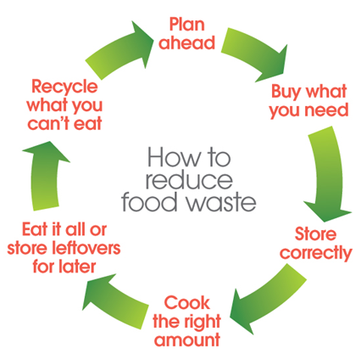

We are approaching the end of this post. To sum up what we said so far, we can state that the world is changing: modern western societies are progressively moving away from the consumerist idea of infinite amounts of food that have dominated the industrial-food business for nearly 100 years. Modern developed countries are progressively realizing that food is a cost from the economic, environmental and energetic point of view in a world where indiscriminate consumption of economic, environmental and energetic resources is not affordable anymore. For this reason, more and more attention is given to food and to the war against its waste.

In the end, we would like to leave you with these beautiful words from [Ava Labuzetta](https://www.thinkdif.co/big-top-tent-sessions/rochester-2?d=Y#_=_), Pollution Prevention Engineer at the New York State Pollution Prevention Institute, that we think efficiently sum up the general concept of this post: “*Food is so intertwined with our society, our economy and our environment. When we talk about reducing food waste, we really talk about realizing these benefits along all three of these categories*”.

1. <http://www.fao.org/3/a-i3991e.pdf>
2. <https://www.wfp.org/hunger/stats>
3. <http://www.triplepundit.com/special/sustainability-whirlpool/food-waste-next-frontier-circular-economy/>
4. <http://www.triplepundit.com/special/sustainability-whirlpool/food-waste-next-frontier-circular-economy/>
5. <https://ec.europa.eu/food/safety/food_waste/eu_actions_en>
6. <http://ec.europa.eu/priorities/jobs-growth-and-investment/towards-circular-economy_en>